**BUSINESS MANAGEMENT SYSTEM:**

**Introduction:** In the dynamic landscape of contemporary business, effective management is the linchpin for organizational success. The Business Management System (BMS) emerges as a comprehensive solution, harmonizing technology, processes, and human capital to propel businesses forward. This introduction sets the stage for a closer examination of the critical role a BMS plays in optimizing operations, fostering innovation, and ensuring adaptability in a rapidly changing market. In the dynamic realm of contemporary business, effective management serves as the linchpin for organizational triumph. Enter the Business Management System (BMS), a sophisticated solution that harmonizes technology, processes, and human capital to propel businesses towards innovation and adaptability.

**Scenario:** In today's fast-paced and competitive business landscape, organizations are grappling with the complexities of managing a diverse workforce while adhering to stringent regulatory requirements. The Business Management System (EMS) steps into this scenario as a pivotal solution, offering a unified platform to tackle HR challenges head-on. Whether it's ensuring compliance, fostering effective communication, or optimizing processes, the EMS is designed to empower organizations in overcoming the unique obstacles posed by the contemporary business environment. In the contemporary business landscape, organizations face a multifaceted scenario in managing their workforce. The rapid evolution of technology, coupled with globalization, has given rise to diverse and dispersed teams. This dispersion brings challenges in communication, collaboration, and maintaining a cohesive corporate culture. Simultaneously, navigating the complex web of local and international regulations has become increasingly intricate, demanding meticulous attention from HR professionals.

**Objective:** The primary objective of the Business Management System is to revolutionize the way organizations handle their human resources. By leveraging advanced automation and intuitive interfaces, the BMS aims to simplify and streamline HR operations. This includes but is not limited to enhancing the recruitment process, facilitating seamless onboarding, improving attendance and leave management, fostering a culture of performance excellence, and ensuring smooth offboarding procedures. Ultimately, the objective is to empower HR professionals with the tools they need to create a harmonious work environment that promotes employee well-being and organizational success.

**Project Overview:** The Business Management System is a holistic solution encompassing various modules to cover the entire spectrum of the employee lifecycle. From the initial recruitment phase, through ongoing performance management, to the final stages of offboarding, the system provides a cohesive and user-friendly interface.

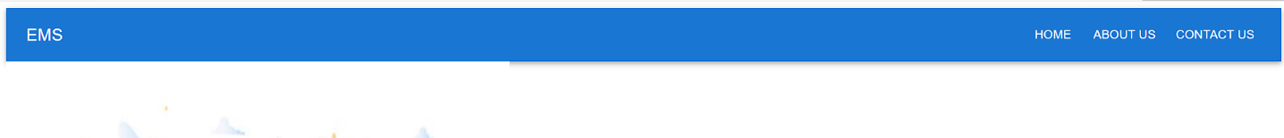

Notable features include efficient recruitment management, automated onboarding processes, meticulous attendance and leave tracking, performance evaluation tools, a self-service portal for employees, and robust compliance and reporting functionalities. The project overview emphasizes how the BMS is poised to become an integral part of an organization's operations, contributing to increased efficiency, compliance, and overall employee satisfaction.

**Coding:**

**APP.JS**

**import React from 'react';**

**import { BrowserRouter as Router, Route, Routes } from 'react-router-dom';**

**import MyAppBar from './Components/assign';**

**import HomePage from './Components/home';**

**import About from './Components/about';**

**import Contact from './Components/contact';**

**const App = () => (**

**<Router> <MyAppBar/> <Routes>**

**<Route path="/" element={<HomePage />} />**

**<Route path="/about" element={<About />} />**

**<Route path="/contact" element={<Contact />} />**

**</Routes>**

**</Router> );**

**export default App;**

**APPBAR.JSX**

**import React from 'react';**

**import { AppBar, Toolbar, Typography, Button } from '@mui/material';**

**import { Link } from 'react-router-dom';**

**const MyAppBar = () => {**

**return (**

**<AppBar position="static"> <Toolbar>**

**<Typography variant="h6" sx={{ flexGrow: 1 }}> EMS</Typography>**

**<Button color="inherit" component={Link} to="/" sx={{ marginRight: 1 }}>**

**Home</Button>**

**<Button color="inherit" component={Link} to="/about" sx={{ marginRight: 1 }}>**

**About Us </Button>**

**<Button color="inherit" component={Link} to="/contact">Contact Us</Button>**

**</Toolbar></AppBar> );**

**};**

**export default MyAppBar;**

**HOME.JSX**

**import React from 'react';**

**import './assign.css';**

**import emp from './emp.png';**

**import emp1 from './emp1.png';**

**const HomePage = () => {**

**return (**

**<div className="Box"> <div className="i1"><img src={emp1}/></div>**

**<div className="i2"><img src={emp}/></div>**

**<div> <center><h1>WELCOME TO<br/>THE<br/>HOME PAGE!</h1></center>**

**</div> </div> );**

**};**

**export default HomePage;**

**ABOUTUS.JSX**

**import React from 'react';**

**import './assign.css';**

**import Typography from '@mui/material/Typography';**

**import Box from '@mui/material/Box';**

**const About = () => {**

**return (**

**<Box className="about-container">**

**<Typography variant="h4" className="about-heading">**

**Welcome to our Employee Management System (EMS) </Typography>**

**<div className="about-content"> <Typography variant="body1">**

**Our Employee Management System (EMS) revolutionizes workforce administration, focusing on the success of your organization through efficient employee engagement.**

**<Typography variant="body1">**

**Security is paramount; our EMS implements robust measures to safeguard sensitive employee data, ensuring compliance with regulations.**

**</Typography> <Typography variant="body1">**

**At [Your Company Name], we offer more than just software; we provide a partnership dedicated to the success and growth of your business.**

**</Typography> </div> </Box> );**

**};**

**export default About;**

**CONTACTUS.JSX**

**import React from 'react';**

**import './assign.css';**

**import Typography from '@mui/material/Typography';**

**import Box from '@mui/material/Box';**

**const Contact = () => {**

**return (**

**<Box className="about-container">**

**<Typography variant="h4" className="about-heading">**

**CONTACT US**

**</Typography> <div className="about-content"><br/><br/><br/>**

**<div className="contact-content"> <Typography variant="body1">**

**Have questions or inquiries? Feel free to reach out to us. Our dedicated support team is here to assist you.**

**</Typography> <Typography variant="body1">**

**For general inquiries, please contact us via email or phone:**

**</Typography><Typography variant="body1"> Email: contact@example.com**

**</Typography> <Typography variant="body1"> Phone: 123-456-7890**

**</Typography> </div> </div> </Box> );**

**};**

**export default Contact;**

**HOME.PNG**

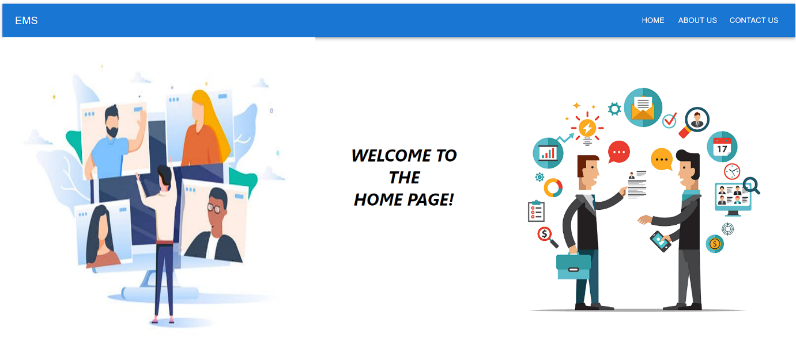

**ABOUTUS.PNG**

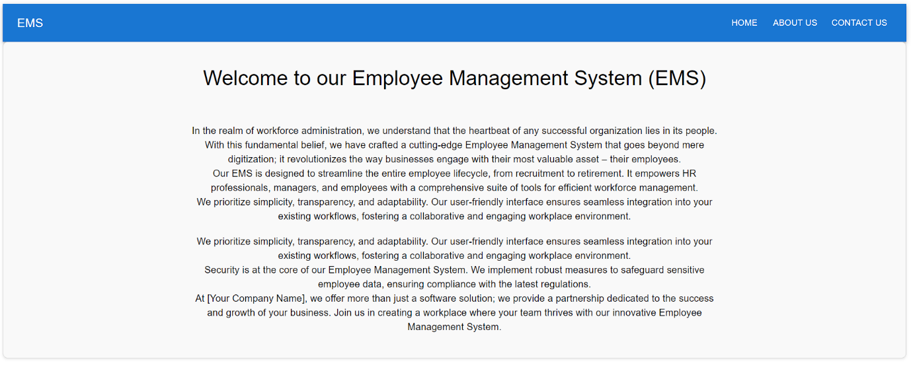

**CONTACTUS.PNG**

